**Commodore 1541 VIA/Parallel-Adapter Rev. 0**

**Module Description**

# Introduction

This adapter board serves as a VIA (6522) adapter for a parallel connection for SpeedDOS in conjunction with a suitable ribbon cable and the User Port Parallel-Adapter (Project 150).

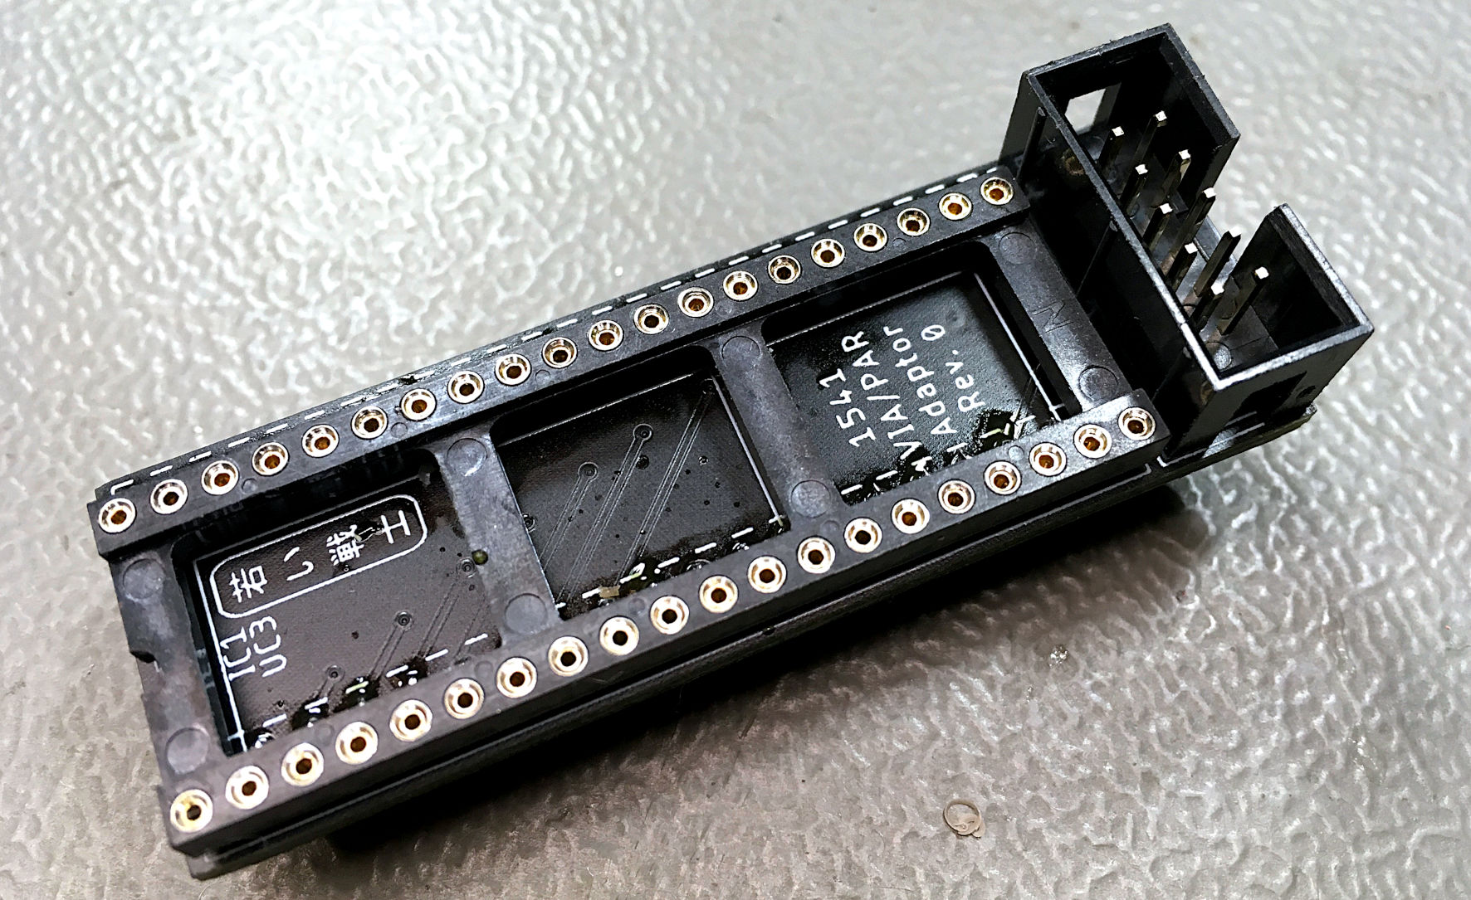

Figure 1: Commodore 1541 VIA/Parallel-Adapter

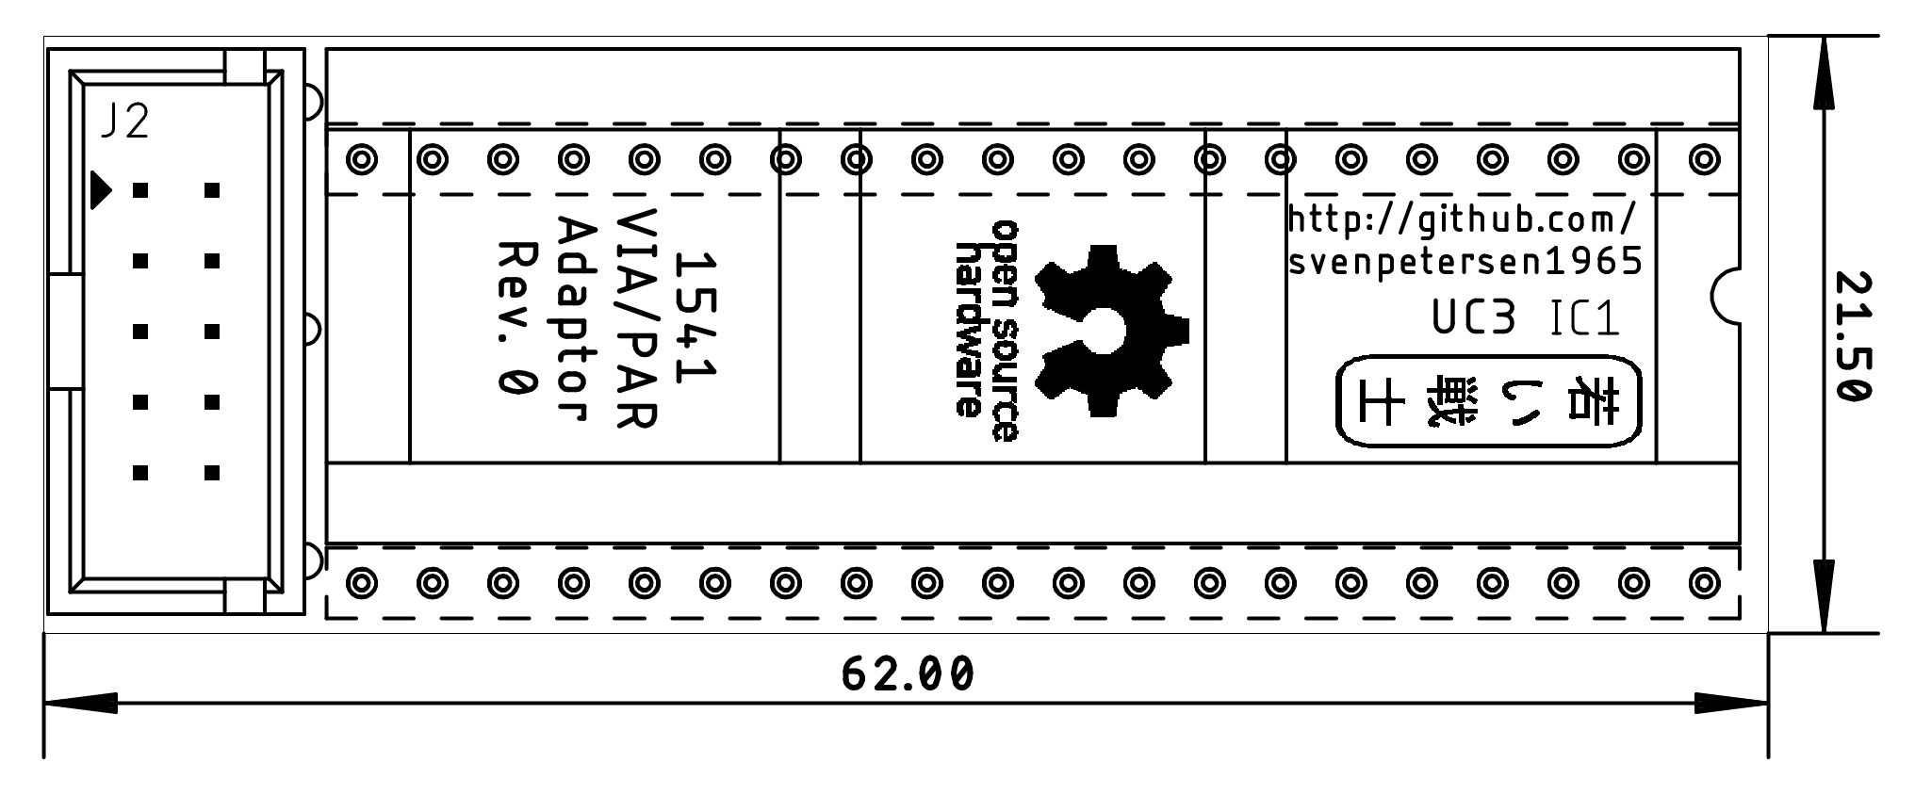

Figure 2: Dimensions

The box connector (2x5 way, 2.54mm pitch) has the following pinout:

|  |  |  |  |
| --- | --- | --- | --- |
| **VIA (pin)** | **J2** | **J2** | **VIA (pin)** |
| CA2 (39) | 1 | 2 | PA0 (2) |
| PA1 (3) | 3 | 4 | PA2 (4) |
| PA3 (5) | 5 | 6 | PA4 (6) |
| PA5 (7) | 7 | 8 | PA6 (8) |
| PA7 (9) | 9 | 10 | CB1 (18) |

The via for the parallel data transmission in a 1541 is UC3.

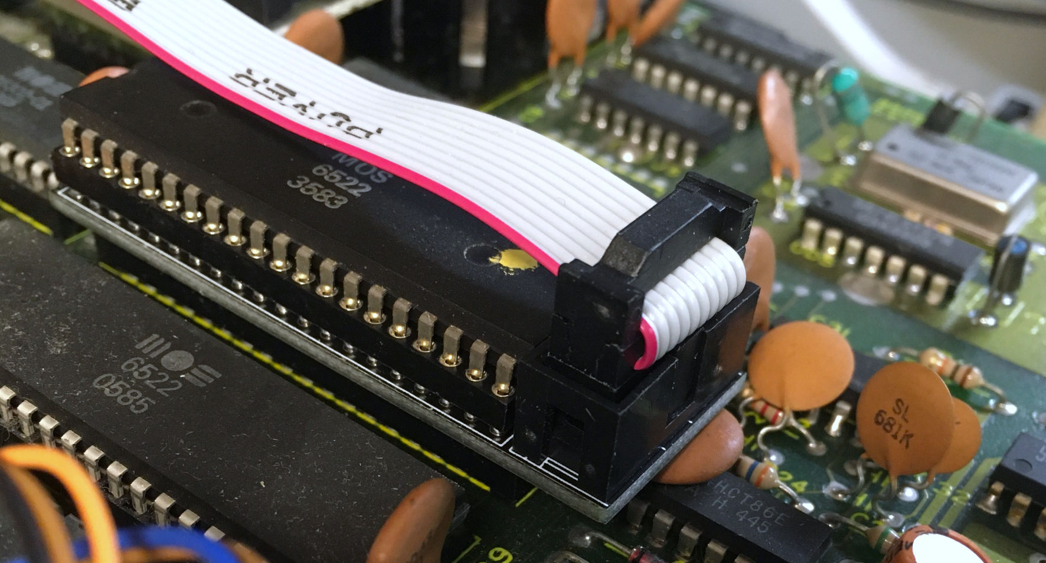

Figure 3: VIA-Parallel-Adapter installed in a 1541

# Installation

Three issues have to be taken care of, when installing the VIA-Parallel-Adapter:

* The VIA (UC3) should be socketed
* The adapter has to be oriented properly (align the notch of the IC, the adapter and the socket on the 1541 PCB
* The pins of box connector on the solder side must not make contact with any component leads

The latter issue can be caused by the leads of C28. This is a 100n capacitor, which can be replaced with a smaller, modern capacitor. In case it is a disc capacitor like in Figure 3, it can be bent over. The adapter has to sit firmly in the socket, though.

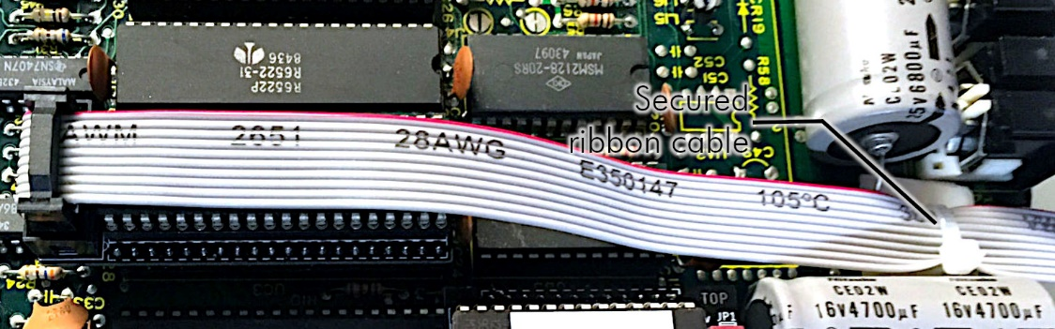

Figure 4: Secured ribbon cable

It is a good idea to secure the ribbon cable with an adhesive cable post and a cable tie for strain relief, after the configuration is fully functional (Figure 4). A ribbon cable exiting the case through the breakout for the fuse is pretty common, I did not experience any problems with it, but one person reported a possible source of problems, here.

An alternative way of exiting the case is the left side of the case. A breakout for the ribbon cable has to be filed into the case, though.

The cable making with IDC connectors does not require any special tools, except a (small) vice for compressing the connector after the ribbon cable was inserted properly. In case you don not feel comfortable with this work, consult this write up about cable making: <http://tech.guitarsite.de/cable_making.html#Ribbon%20Cables>

# Assembly

The Assembly of the VIA-Parallel-Adapter is fairly simple. The precision round pin headers on the solder side need to be aligned to be straight and in the proper distance. For this purpose, the cut strips have to be inserted into the DIP-socket before soldering. Their alignment needs to be checked. They should be fully inserted into the socket and the PCB should be perpendicular. After soldering the pin stripes, the DIP-40 socket can be removed and soldered in on the top side. Some of soldered pins of the pin strips might require to be shortened. The DIP-40 socket should sit straight on the PCB.

Finally, the box connector can be soldered.

The pins of the precision pin strips are pretty delicate and brittle. They should not be bent much, so care must be taken before and while installing them in the socket of the 1541. Square headers must not be used instead, because those might break the sockets and do not sit well in the socket, either.

# Revision History

## Rev. 0

* Prototypes fully functional. For testing consult the documentation of the User Port/Parallel Adapter (Project 150).